COVID-19 Mortality Excess and Cost-Effective Analysis of Different Treatments

**Introduction**

COVID-19 pandemic has created a public health crisis with serious consequences in most countries worldwide, and Mexico has been one of the most affected. On March 21, 2021, the Mexican government reported 2,238,887 accumulated cases of COVID-19 and 203,210 deaths1. This makes it the fourteenth country in the world in the number of confirmed cases and the third in reported deaths.2

Pending edit

Excess mortality [pending explanation] from a disease can be a very useful measure for decision makers, since it allows to evaluate different strategies that attempt to modify and mitigate directly this specific risk in the population. Currently, there are neither studies that have estimated the excess mortality from COVID-19, nor that attempt to evaluate the effectiveness of various strategies to reduce mortality from COVID-19. The estimation of this excess mortality for the Mexican population provides an opportunity to evaluate possible strategies to reduce the mortality of COVID-19 even if they have not yet been applied in the country.

The aim of this analysis is twofold. First, to estimate the COVID-19 specific mortality for the population over 45 years of age in Mexico using relative survival methods. Second, to quantify the costs, effectiveness and cost-effectiveness using a microsimulation model of different treatments that aim to reduce the COVID-19-specific mortality. All calculations, models and graphs were done using R,3 and Rstudio software.4

**Methods**

*Data*

We used information from the National Epidemiological Surveillance System base for monitoring possible cases of COVID-19. This dataset includes people tested for SARS-CoV-2 in Mexico and contains only data obtained from test done on suspicious persons when detected in the medical units of the health sector5. Database is filtered to select only people with a positive test result, older than 44 years and that have been hospitalized. Individuals in the database are classified by sex, age group and if the patient required intubation. Background mortality rates for Mexican population in 2020 come from the National Population Council demographic indicators6.

Pending information about costs and effects

*Relative Survival and specific probabilities of death*

Relative survival and excess mortality analysis is a methodology that deals with registries of a cohort diagnosed with a disease and follow up its time and vital status, though causes of death are unknown or not clear.7

Relative survival consists in the ratio between the survival of the cohort analyzed $S_{O}(t)$ and the expected survival of the population $S_{p}(t)$ normally obtained from population mortality information. Relative survival is defined as 7,8 This methodology allows to report overall hazard $λ_{O_{i}}(t)$ over time, which could be written as the sum of the disease-specific hazard $λ_{E_{i}}\left(t\right)$ and the average background population hazard 7.

Disease-specific hazard or “excess-hazard” estimates allows to compute disease-specific mortality and extrapolate intervention effects from RCTs. By deriving the disease-specific mortality ($μ_{Dis}$) and the background specific mortality by sex and age ($u_{SA}$) from $λ_{E_{i}}\left(t\right)$ and $λ_{P_{i}}(t)$, and assuming the hazard as an additive function of each specific mortality, overall mortality could be defined as 9:

If I want to incorporate the effect of an intervention, such as a pharmacological treatment for a disease, $μ_{Dis}$ is modified. Published Hazard Ratios of clinical trials $(HR_{CT}$) could decrease or increase $μ_{Ovall}$ by changing $μ_{Dis}:$

$$μ_{Dis}^{*}=μ_{Dis}*HR_{CT}$$

$$μ_{Ovall}^{*}=μ_{Dis}^{*}+μ_{SA }$$

Pending: Edition and a more detailed description

*Decision Model*

We estimated disease specific (${\overline{λ}}_{Dis}$) and background specific hazards for sex and age (${\overline{λ}}_{SA}$) for 50 days using the Mexican population positive for COVID-19 as a cohort and the expected mortality as the daily death rates projected for 2020 using modified functions of the *relsurv*10 package in R. These estimates allowed us to calculate disease-specific and background specific mortality probabilities by age group and sex assuming an exponential distribution of the hazard rate at a specific time:

$$P{\left(die\right)}_{Cov}=1-\exp\left(- {\overline{λ}}_{Dis}\right)$$

Probabilidad de morir 1 – exp de todas las tasas y luego 1 menos

$$P{\left(die\right)}_{Other Causes}=1-exp⁡(- {\overline{λ}}_{SA})$$

These outputs were employed to simulate the trajectory of individuals infected with COVID-19 in Mexico for 50 days and incorporate the effects of different strategy treatments that have shown promising evidence in reducing mortality in people with Covid-19: Dexamethasone11, Remdesivir12 and Remdesivir with Baricitinib13. The of these treatments was applied to obtain the COVID-19 specific death probabilities under the effect of different drugs:

$${\overline{λ}}_{Dis with Dexa}= {exp⁡(log⁡(\overline{λ}}_{Dis})+log⁡(HR_{CTDexa}))$$

$${\overline{λ}}_{Dis with Remd}= {exp⁡(log⁡(\overline{λ}}_{Dis})+log⁡(HR_{CTRemd}))$$

${\overline{λ}}_{Dis with Remd and Bari}= exp⁡(\log\left({\overline{λ}}_{Dis with Remd}\right)+\log\left(HR_{CTRemd and Bari} \right))$

*

In this case, since the hazard ratio is reported comparing a group treated with Remdesivir with another treated with Remdesivir and Baricitinib, the effect of Baricitinib is added to ${\overline{λ}}_{Dis with Remd.}$

$$P{\left(die\right)}_{Cov with Dexa}=1-\exp\left(- {\overline{λ}}_{Dis with Dexa}\right)$$

$$P{\left(die\right)}_{Cov with Remd}=1-\exp\left(- {\overline{λ}}_{Dis with Remd}\right)$$

$$P{\left(die\right)}_{Cov with Remd and Bari}=1-\exp\left(- {\overline{λ}}_{Dis with Remd and Bari}\right)$$

The microsimulation model utilized in this analysis is an adaptation of the state-transition microsimulation algorithm proposed for modeling for health decision sciences14. Implementation requires a model of the life cycle of a sick individual. This life cycle should be divided into mutually exclusive and collectively exhaustive states. Proposed states are: Sick of COVID-19, the initial state for all the individuals in the cohort, death from COVID-19 and death from other causes. Transition probabilities between states are $P{\left(die\right)}_{Cov}$ and $P{\left(die\right)}_{Other Causes}$.

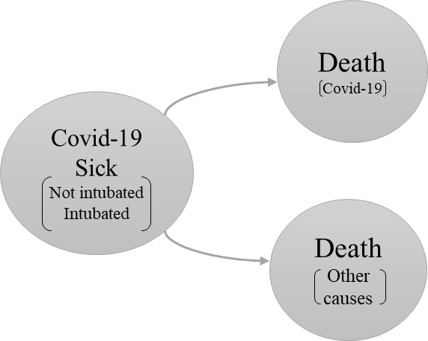

Figure 1 Model structure

Pending: Edition and a more detailed description

*Cost effectiveness and Sensitivity analysis*

Because Dexamethasone is not recommended for non-intubated patients and Remdesivir is a drug that has shown more efficacy in less critical states, the simulated population was divided into two cohorts: Hospitalized and intubated patients. We carry out a cost-effectiveness analysis for the following strategies:

Hospitalized population

1. Treat with Remdesivir
2. Treat with Remdesivir and Baricitinib
3. No treatment

Intubated population

1. Treat with Dexamethasone
2. No treatment

Incremental Cost-Effectiveness Ratio (ICER) is incorporated to determine the best strategy for each cohort. The ICER estimation was carried out with *dampack*15package*.* The cost-effectiveness analysis was developed with a probabilistic sensitivity analysis to incorporate uncertainty in the information on the effectiveness of treatments and hospital costs. Supplemental material of this document includes the parameters utilized in the model.

*Costs*

Costs includes expected daily costs by hospitalization and an estimation of the treatment costs based on information reported by the Mexican Institute of Social Security 16. All costs are reported in Mexican pesos.

*Effects*

Effectiveness is expressed in Life Years Gained (LY) by strategy. To calculate this, we take the people that survived after the simulated 50 days and added the expected years of life according to their sex and age.

Pending: Go deeper into this explanation

**Results**

Pending: Cohort characteristics data table

*COVID-19 specific hazard*

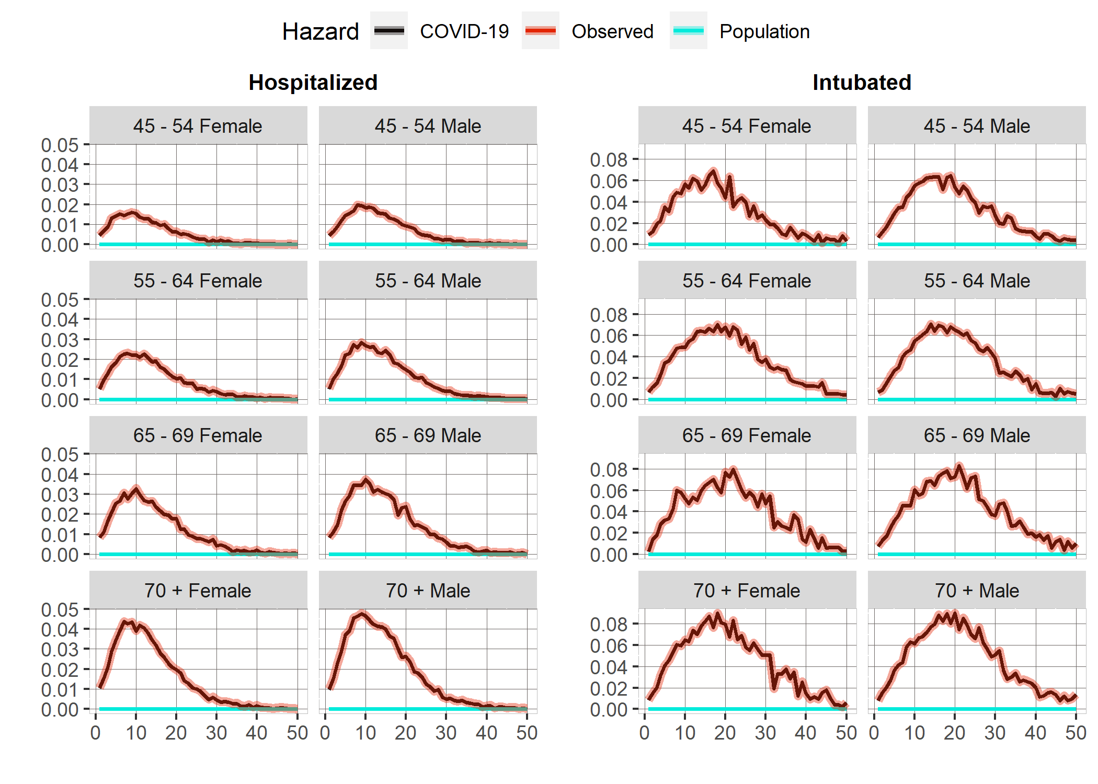

Figure 2: COVID-19 Daily hazards by cohort, age and sex group. Source: Author´s own creation with information published by Mexico´s Ministry of Health.

The results show us that the COVID-19 specific hazard practically represents the total hazard, since the daily background population mortality rates are near 0. The highest hazard is around day 10 for hospitalized people, while in the intubated cohort, the high hazard rates remain for more days, extending beyond 20 days for all age groups. For the hospitalized cohort hazard increases at higher ages and is systematically higher for Male sex. Practically all observed hazard decreases to the expected population mortality level after day 40.

However, hazards are practically double for the intubated cohort. Also, the intubated cohort's hazards are very similar after 55 years, and the differences by sex are much less notable. The effect of COVID-19 does not disappear for the last age group, and even on day 60, the mortality levels are higher than expected.

*Cost-effectiveness Analysis*

The cost-effectiveness analyses presented come after having carried out a probabilistic sensitivity analysis with 1,000 sets of parameters. The distribution of parameters is in the supplemental material.

Pending: Edition and a more detailed description

*Hospitalized cohort*

If no treatment is applied, the expected life years are 7.54. When the population is treated with Baricitinib and Remdesivir is applied, the expected life years gained are 2.08.

|  |  |  |  |  |  |
| --- | --- | --- | --- | --- | --- |
| **Cost-Effectiveness Analysis: Hospitalized** | | | | | |
| Strategy | Cost | Effect | Incremental Cost | Incremental Effect | ICER |
| *No Treatment* | $317,932.60 | 7.542261 | - | - | - |
| *Remdesivir and Baricitinib* | $488,107.00 | 9.629469 | $170,174.40 | 2.087208 | 81532.0754 |
| *Remdesivir* | $406,372.00 | 8.548145 | - | - | - |

Figure 3: ICERs of the three different strategies for the hospitalized cohort

The results only display incremental costs, effects and ICER´s for the “No treatment” and “Remdesivir and Baricitinib” strategies because “Remdesivir” is a weakly dominated strategy as can be seen in the efficient frontier, which implies that the “Remdesivir and Baricitinib” strategy is always chosen if the willingness to pay increases above the “No treatment” limit.

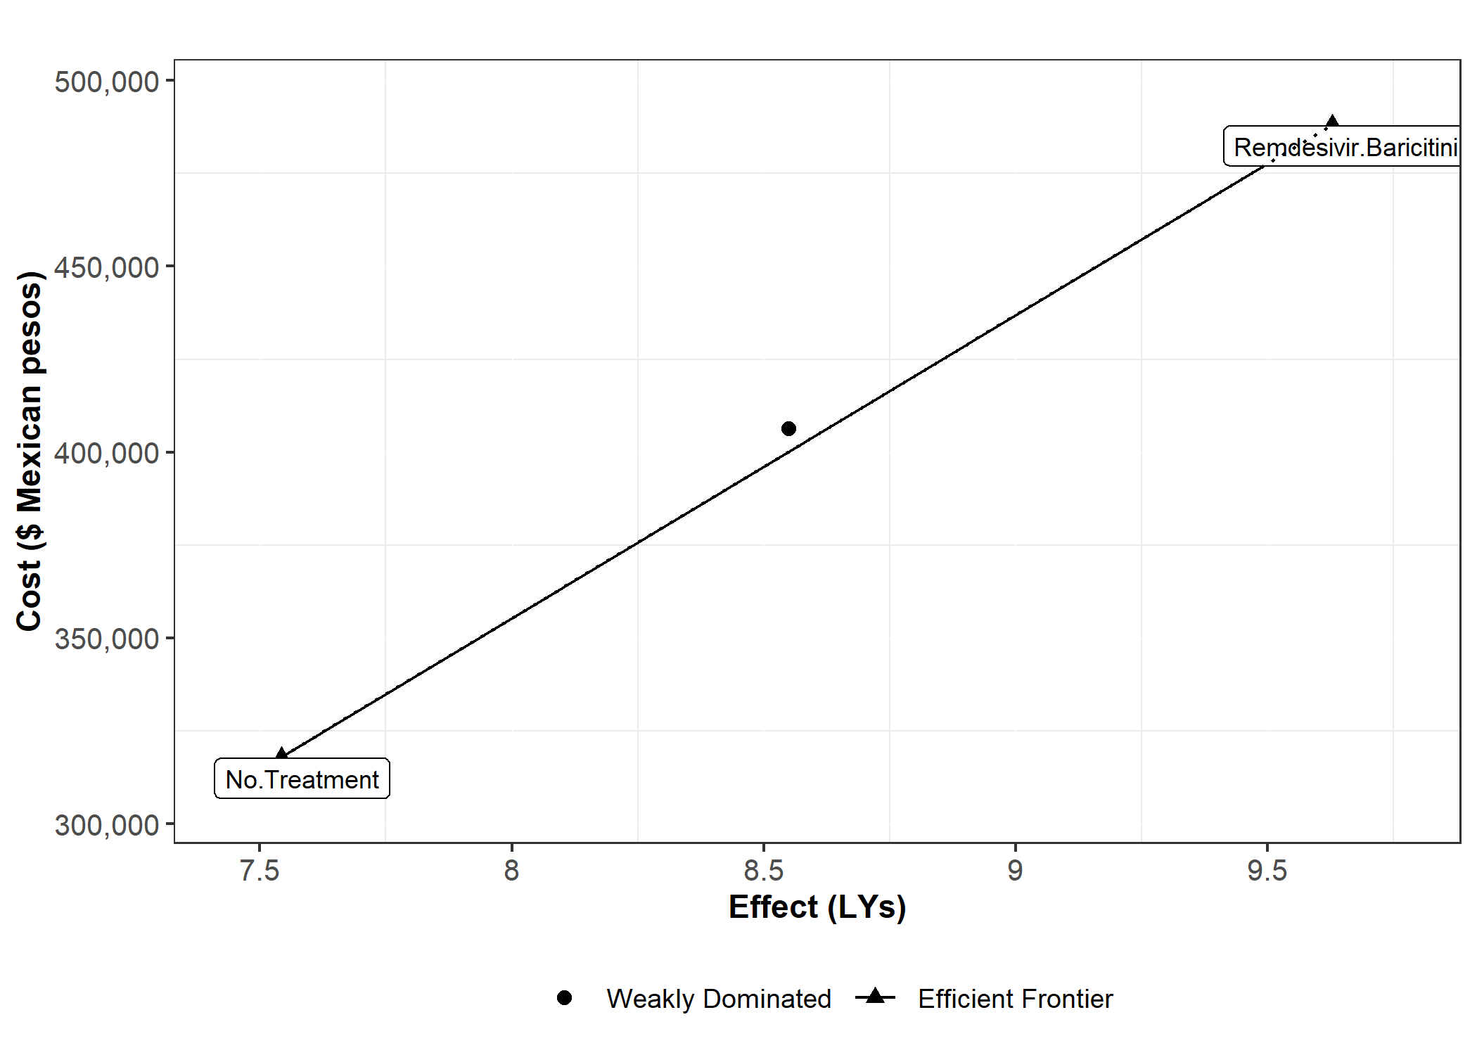

Figure 4: Efficient frontier of strategies for the hospitalized patient cohort

If the willingness to pay surpasses $87,922.64 Mexican pesos per life-year, gained “Remdesivir and Baricitinib” strategy has a greater probability of being more cost-effective than the other two strategies. Below this point, “No treatment” is probably more cost-effective.

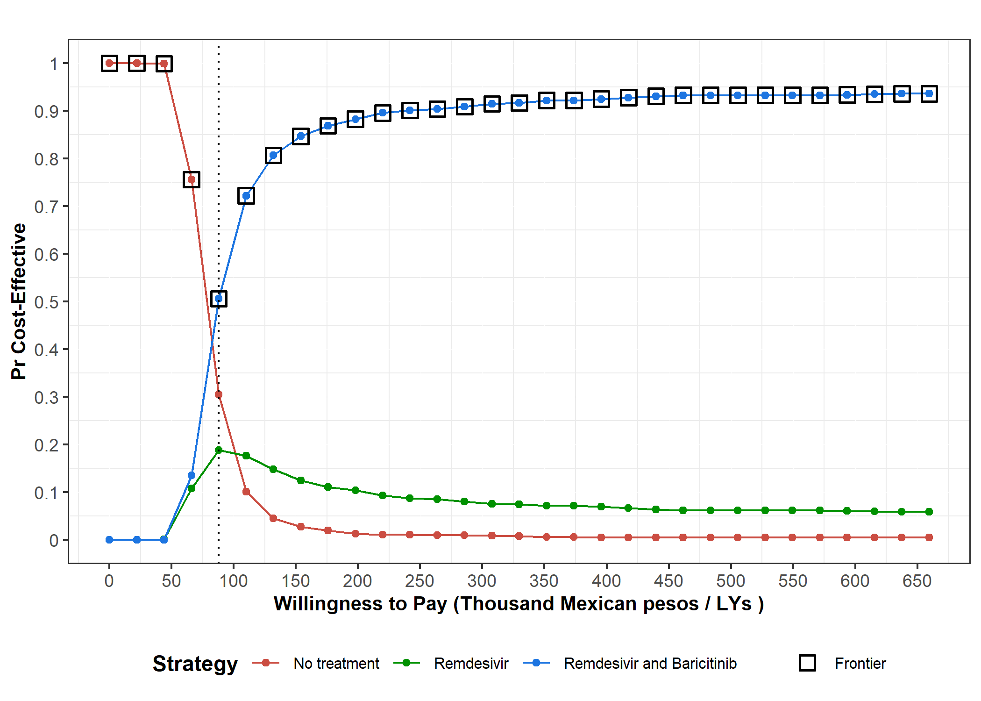

Figure 5: Probability of a strategy for hospitalized patients of being cost-effective under different willingness to pay. Dotted line indicates the threshold where one strategy outperforms another in probability.

Pending: Edition and a more detailed description

*Intubated cohort*

The expected Life Years gained by dexamethasone are 1.8. The vast majority of dexamethasone costs come from the increase in individuals who survived the treatment and who saw their hospital costs increase. The price of the drug is meager (approximately 4 Mexican pesos).

|  |  |  |  |  |  |
| --- | --- | --- | --- | --- | --- |
| **Cost Effectiveness Analysis: Intubated** | | | | | |
| Strategy | Cost | Effect | Incremental Cost | Incremental Effect | ICER |
| *No Treatment* | $923,677.90 | 2.07726 | - | - | - |
| *Dexamethasone* | $1,200,217.20 | 3.898768 | $276,539.30 | 1.821508 | 151818.878 |

Figure 6: ICERs of the three different strategies for the intubated patient cohort

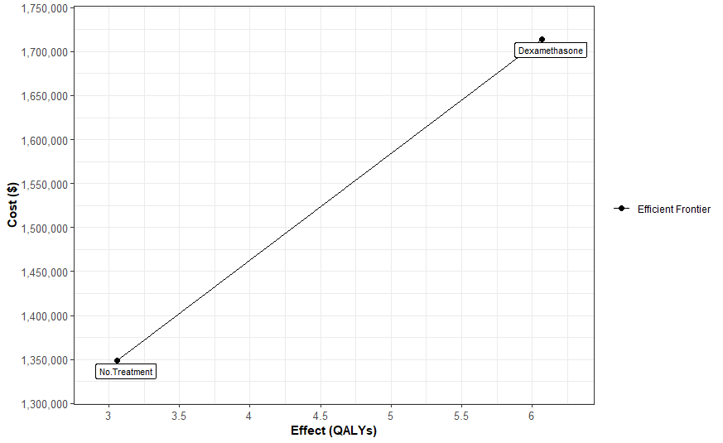

Figure 7: Efficient frontier of strategies for the intubated patient cohort

In this case, “Dexamethasone” strategy is more cost-effective when the willingness to pay increases over $153,8646 per life year gained.

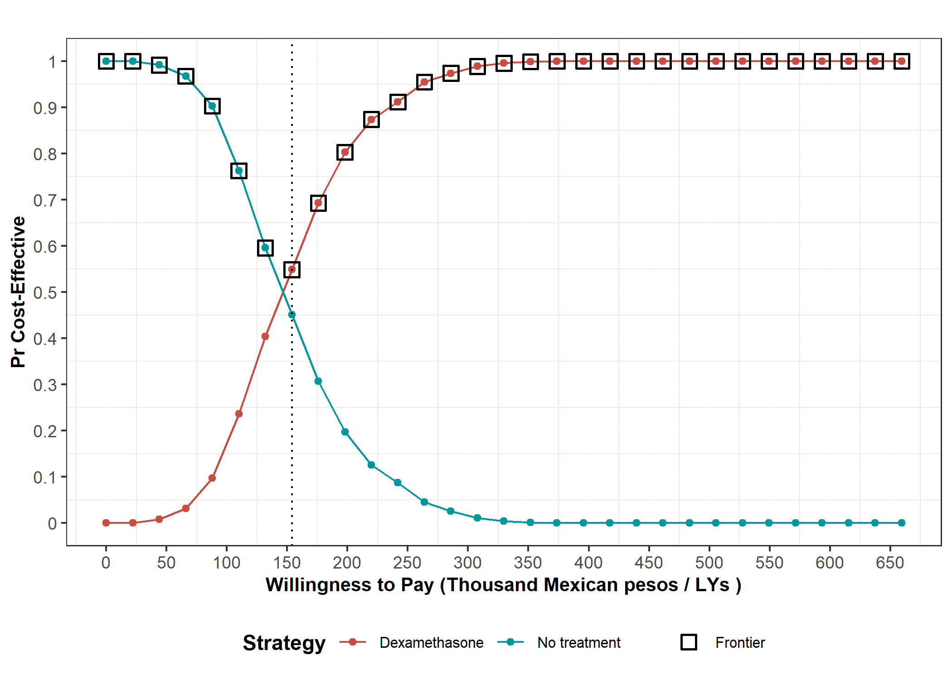

Figure 8: Probability of a strategy for intubated patients of being cost-effective under different willingness to pay. Dotted line indicates the threshold where Dexamethasone strategy outperforms No treatment in probability.

Pending: Edition and a more detailed description

**Discussion**

One of the limitations of this work is that the model considers that individuals classified as sick during all cycles are hospitalized, when it is possible that they have already been discharged. Unfortunately, we do not count with information about hospitalization times to estimate the average stay per individual.

**References**

1 Secretaria de Salud. Informe Técnico Diario COVID-19 MÉXICO. 2020. https://www.gob.mx/cms/uploads/attachment/file/593517/Comunicado_Tecnico_Diario_COVID-19_2020.11.19.pdf.

2 John Hopkins University. COVID-19 Dashboard by the Center for Systems Science and Engineering (CSSE) at Johns Hopkins University (JHU). 2020. https://coronavirus.jhu.edu/map.html (accessed Dec 9, 2020).

3 R Core Team. R: A Language and Environment for Statistical Computing. 2013. http://www.r-project.org.

4 Rstudio Team. RStudio: Integrated Development for R. 2020. http://www.rstudio.com/.

5 Secretaría de Salud. Información referente a casos COVID-19 en México. Bases datos COVID 19 en México. 2020; published online Nov 19. https://datos.gob.mx/busca/dataset/informacion-referente-a-casos-covid-19-en-mexico/resource/3d7fb4a8-5763-4dba-a23f-a20edc7783f7 (accessed Dec 9, 2020).

6 Consejo Nacional de Población (CONAPO). Proyecciones de la Población de los Municipios de México, 2015-2030. 2019; published online Sept 22. https://www.gob.mx/conapo/documentos/proyecciones-de-la-poblacion-de-los-municipios-de-mexico-2015-2030 (accessed Dec 9, 2020).

7 Pohar Perme M, Klemen P. Pohar Perme, Pavlič - 2018 - Nonparametric relative survival analysis with the R package relsurv.pdf. *J Stat Softw* 2018; **87**. DOI:https://doi.org/10.18637/jss.v087.i08.

8 EDERER F, AXTELL L, CUTLER S. The relative survival rate: a statistical methodology. *Natl Cancer Inst Monogr* 1961; **6**: 101.

9 Alarid-Escudero F, Kuntz KM. Potential Bias Associated with Modeling the Effectiveness of Healthcare Interventions in Reducing Mortality Using an Overall Hazard Ratio. *Pharmacoeconomics* 2020; **38**: 285–96.

10 Pohar Perme M. Package ‘ relsurv ’. 2018. https://cran.r-project.org/web/packages/relsurv/relsurv.pdf.

11 The RECOVERY Collaborative Group. Dexamethasone in Hospitalized Patients with Covid-19 — Preliminary Report. *N Engl J Med* 2020; : 1–11.

12 Beigel JH, Tomashek KM, Dodd LE, *et al.* Remdesivir for the Treatment of Covid-19 — Final Report. *N Engl J Med* 2020; **383**: 1813–26.

13 Marconi VC, Palacios GMR, Hsieh L, *et al.* Baricitinib plus Remdesivir for Hospitalized Adults with Covid-19. 2020; : 1–13.

14 Krijkamp EM, Alarid-Escudero F, Enns EA, Jalal HJ, Hunink MGM, Pechlivanoglou P. Microsimulation Modeling for Health Decision Sciences Using R: A Tutorial. *Med Decis Mak* 2018; **38**: 400–22.

15 Alarid-Escudero F, Krijkamp EM, Pechlivanoglou P, *et al.* A need for change! A coding framework for improving transparency in decision modeling. *Pharmacoeconomics* 2019; **37**: 1329–1339.

16 H. Consejo Técnico. Acuerdo relativo a la Aprobación de los Costos Unitarios por Nivel de Atención Médica actualizadas al año 2021. México: Diario Oficial de la Federación, 2020.

**Appendix**

|  |  |
| --- | --- |
| **Table 1: Parameter microsimulation model: Hospitalized Cohort** | |
| **Parameters** | **Value** |
| *Number of individuals* | 200,693 |
| *Time horizon* | 50 days |
| *Number of states* | 3 |
| *Name of states* | Cov-19 + |
| Cov-19 Dead |
| Other causes Dead |
| *Annual discount rate for costs* | 0.0165 |
| *Annual discount rate for efectiveness* | 0.0165 |
| **Daily healthcare costs** | |
| *Hospitalized COVID-19 patient* | Gamma distribution: ꓗ = 8, θ = 1159 |
| *Dead patient* | 0 |
| **Intervention daily costs** | |
| *Remdesivir* | $6,188.00 |
| *Baricitinib* | $3,672.00 |
| **Intervention Effect** | |
| *Remdesivir* | Lognormal distribution: μ = 0.73, σ = 0.17 |
| *Baricitinib* | Lognormal distribution: μ = 0.65, σ = 0.26 |
| *All monetary amounts are expressed in Mexican pesos | |

|  |  |
| --- | --- |
| **Table 2: Parameter microsimulation model: Intubated Cohort** | |
| **Parameters** | **Value** |
| *Number of individuals* | 38,884 |
| *Time horizon* | 50 days |
| *Number of states* | 3 |
| *Name of states* | Cov-19 + |
| Cov-19 Dead |
| Other causes Dead |
| *Annual discount rate for costs* | 0.0165 |
| *Annual discount rate for efectiveness* | 0.0165 |
| **Daily healthcare costs** | |
| *Intubated COVID-19 patient* | Gamma distribution: ꓗ = 8, θ = 5518.87 |
| *Dead patient* | 0 |
| **Intervention daily costs** | |
| *Dexamethasone* | $4 |
| **Intervention Effect** | |
| *Dexamethasone* | Lognormal distribution: μ = 0.64, σ = 0.11 |
| *All monetary amounts are expressed in Mexican pesos | |